**Name:** Ahmed Mohamed Yousef Mohamed **Topic**: Artificial Intelligence

**Code:** 1097

|  |
| --- |
|  |

**Application Brief**

Artificial Intelligence and Machine Learning are products of both science and myth. The idea that machines could think and perform tasks just as humans do is thousands of years old. The cognitive truths expressed in AI and Machine Learning systems are not new either. It may be better to view these technologies as the implementation of powerful and long-established cognitive principles through engineering.

We should accept that there is a tendency to approach all important innovations as a Rorschach test upon which we impose anxieties and hopes about what constitutes a good or happy world. But the potential of AI and machine intelligence for good does not lie exclusively, or even primarily, within its technologies. It lies mainly in its users. If we trust (in the main) how our societies are currently being run then we have no reason not to trust ourselves to do good with these technologies. And if we can suspend presentism and accept that ancient stories warning us not to play God with powerful technologies are instructive then we will likely free ourselves from unnecessary anxiety about their use.

|  |
| --- |
| **Links**  Github link : |

**Screen Shots of WEB site**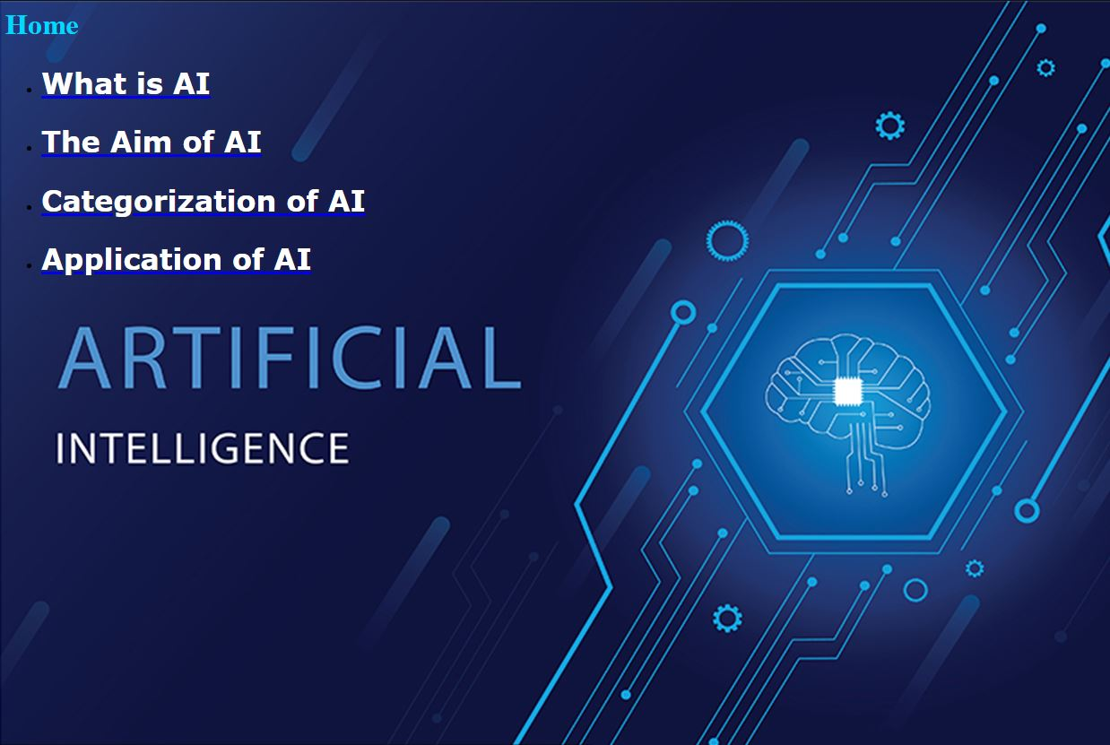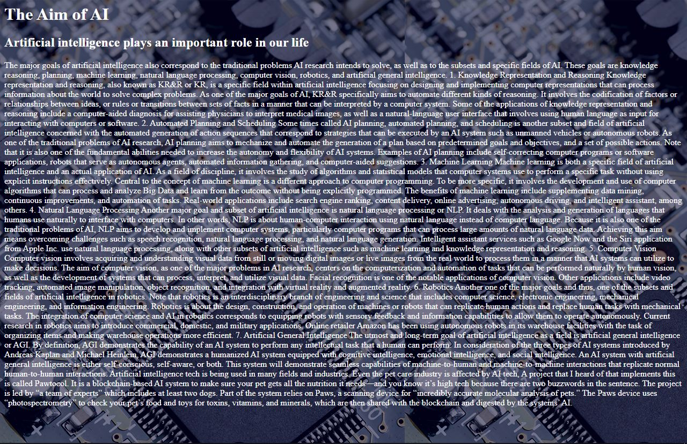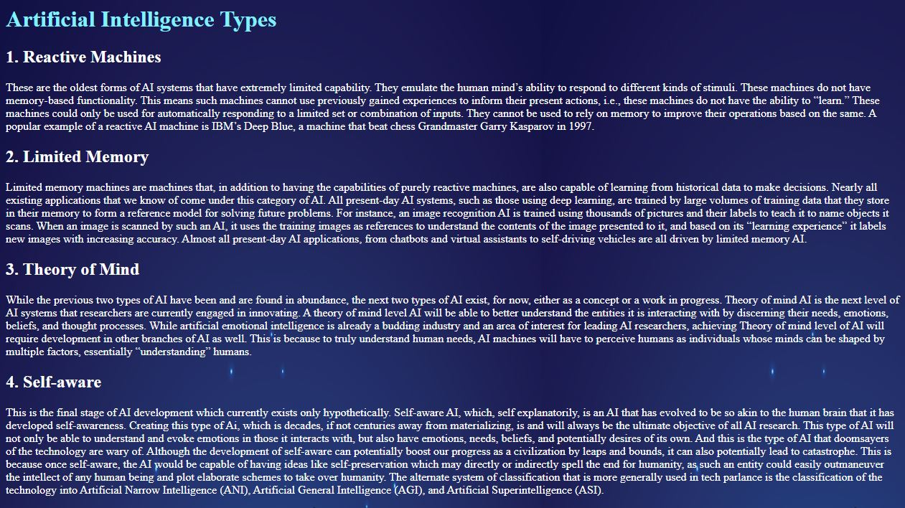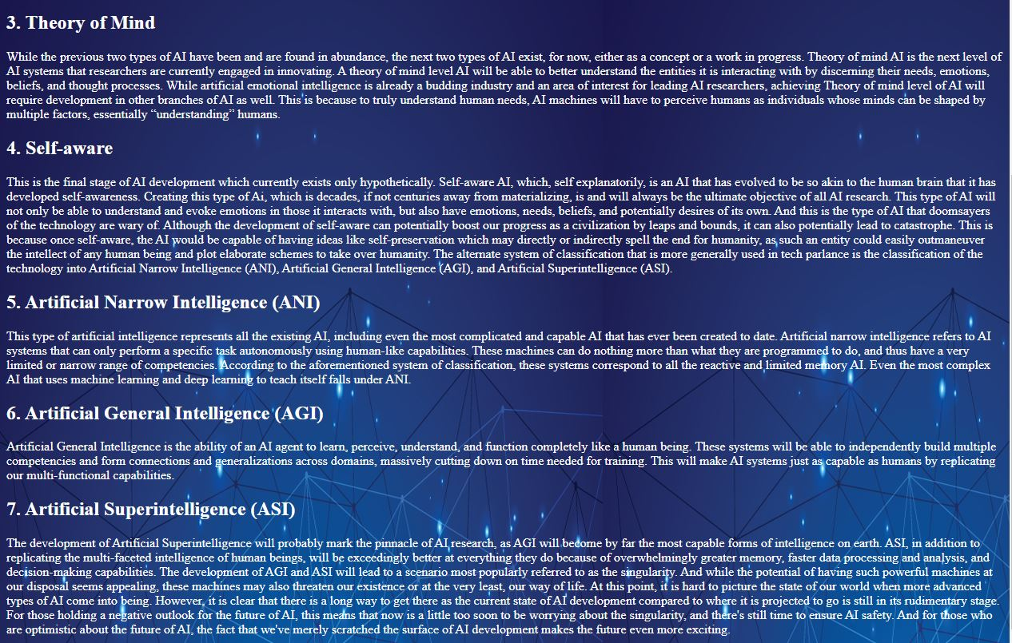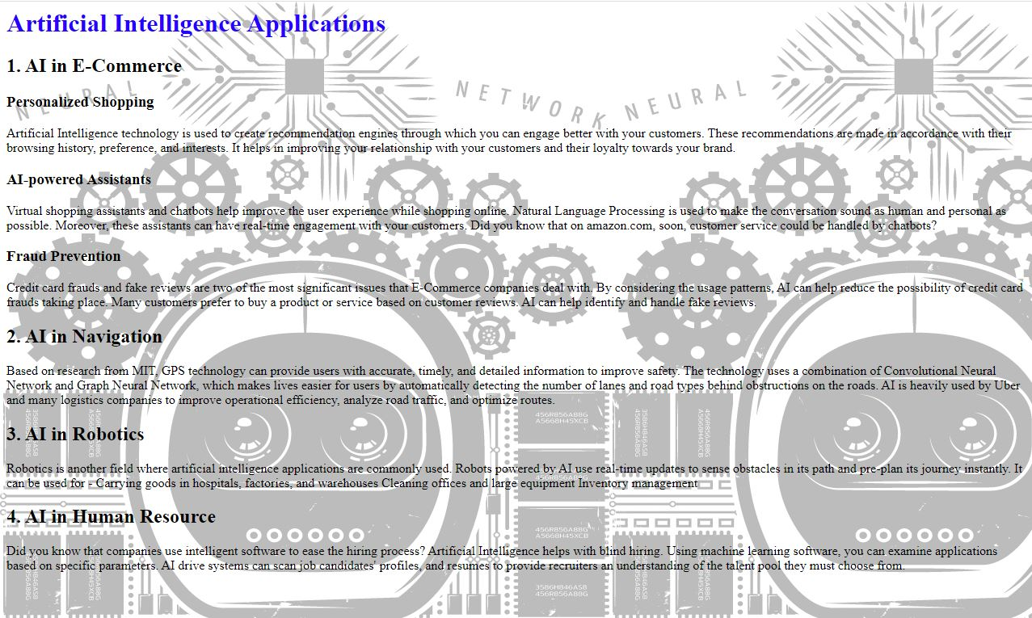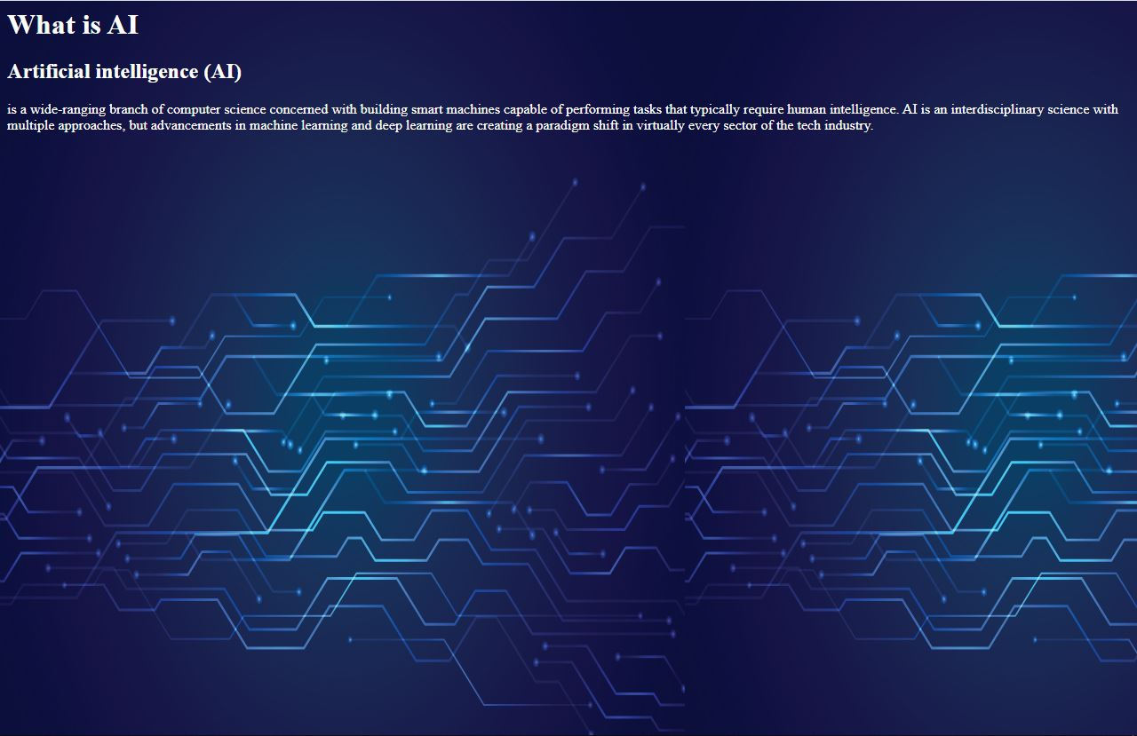

**Screen Shots of Code source**